Name : Saurabh Jadhav

Topic : Creating Web server to access a web page by using auto script.

Assignment no. : 9

1. Create an EC2 instance using
2. Amazon linux AMI
3. t2.micro instance type
4. Create new key pair.
5. Select existing security group with all traffic.
6. In advance setting provide the automatic code.

#!bin/bash

Yum update -y

Yum install httpd -y

Systemctl start httpd

Systemctl enable httpd

Systemctl status httpd

Echo “My web page” >> /var/www/html/index.html

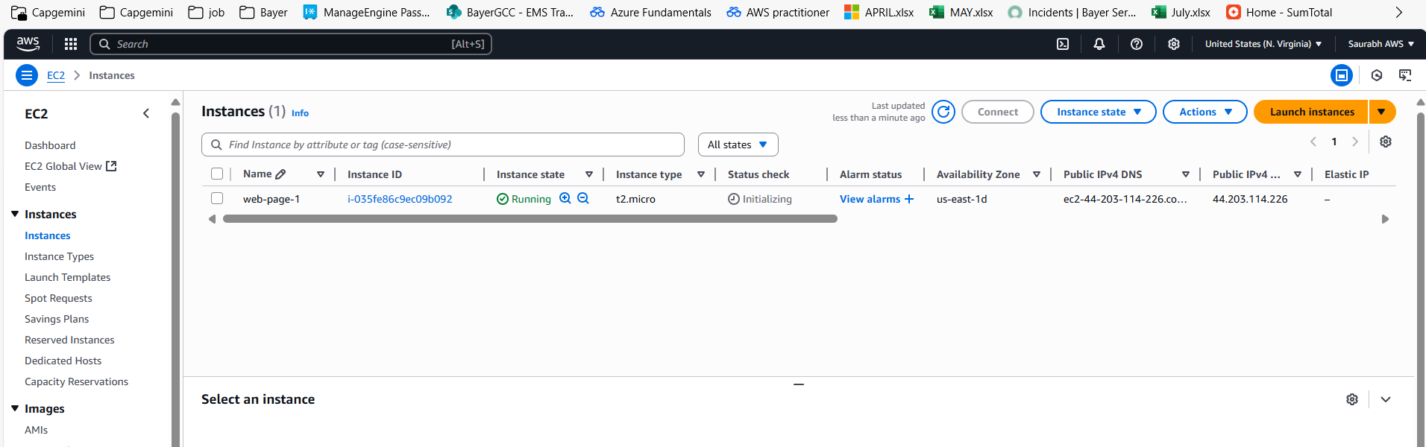

1. Access the web page using the public DNS url

